Architecture Design Document

Trip Reservation System

Andrés Mauricio Castro Quintero

Version 1.0

Revision History

The revision history cycle begins once changes or enhancements are requested after the initial version of the Software Architecture Document has been completed.

Version | Description | Author
1.0 | Initial version of the architecture. | Andrés Mauricio Castro
Table of Contents

1. Introduction 1
1.1. Purpose 1
1.2. Scope 1
1.3. Definitions, Acronyms, and Abbreviations 2
2. Architectural Representation 2
3. Architectural Goals and Constraints 3
3.1. Security 3
3.2. Persistence 3
3.3. Performance 4
4. Use-Case View 4
4.1. Actors 5
5. Logical View 5
5.1. Overview 5
6. Process View 8
7. Module Decomposition View 10
8. Data View 13
9. Deployment View 16
10. Issues and concerns 17

Software Architecture Document Template

Introduction
This document provides a high level overview of the architecture, for a trip reservation system.

The document provides a high-level description of the goals of the architecture, the use cases supported by the system, architectural styles and components that have been selected to best achieve the use cases.

The different views of the architecture are represented by UML models, including the static and the dynamic view, and how the external integrations are achieved in a cloud environment.

Purpose
The architecture document is intended to capture and convey the significant architectural decisions which have been made on the system.

In order to depict the software as accurately as possible, the structure of this document is based on the “4+1” model view of architecture.

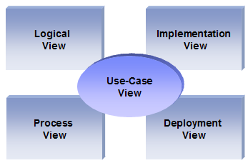
The “4+1” View Model allows various stakeholders to find what they need in the software architecture.

Scope

This document describes the aspects of the Trip Reservation System design that are considered to be architecturally significant; that is, those elements and behaviors that are most fundamental for guiding the construction, and for understanding this project as a whole. Stakeholders who require a technical understanding of the system are encouraged to start by reading this document, then reviewing the UML models.

Definitions, Acronyms, and Abbreviations
- Mongo – Mongo NonSQL Database
- Apache CAMEL - Open source framework for enterprise integrations
- REST – Representational State Transfer
- MySQL – relational database management system (RDBMS)
- UML – Unified Modeling Language
- User - This is any user who is registered on the website
- EIP – Enterprise Integration Patterns
- SOA – Service Oriented Architecture

Architectural Representation
This document details the architecture using the views defined in the “4+1” model, but using the RUP naming convention. The views used to document the architecture are:

Use Case view
Audience: All the stakeholders of the system, including the end-users.
Area: Describes the set of scenarios and/or use cases that represent some significant, central functionality of the system. Describes the actors and use cases for the system, this view presents the needs of the user and is elaborated further at the design level to describe discrete flows and constraints in more detail.
Related Artifacts : Use-Case Model

Logical view
Audience: Designers.
Area: Describes the most important use-case realizations and business requirements of the system.
Related Artifacts: Design model

Data view
Audience: Data Architects, Programmer.
Area: Describe the schema structure to store the required information.
Related Artifacts: Documents Schema Model.

Implementation view
Audience: Programmers.
Area: Software components: describes the modules and subsystems of the application.
Related Artifacts: Classes and packages diagrams.

Deployment view
Audience: Integrators.
Area: Describes the infrastructure and deployment model required for the application; describes the mapping of the software onto the hardware and shows the system's distributed aspects
Related Artifacts: Deployment diagram.

Architectural Goals and Constraints
Backend
The Trip Reservation System will be deployed on the cloud. The solution backend needs to be integrated with third party systems, through a uniform interface, ensuring interoperability and loose coupling, so for this target, a set of REST services will be in place.
We must ensure the solution is highly scalable; to achieve this feature, the backend is not going to keep any state, enabling the solution to scale infinitely, such as defined by the cloud principles (at least theoretically).
All the communication with the end user has to comply with public HTTPS.

Security

All communication channels, and transferred data should be secured. For this purpose, we are going to leverage the security capabilities provided by the integration layer. This is detailed in the security subsection.

The organization can protect sensitive data and applications both on-premises and in the cloud with integrated multi-factor authentication, ensuring secure local and remote access.

Persistence

Data persistence will be addressed using schema-less database, with the capability to scale, in order to handle the amount of massive transactions.

Performance

There is no particular constrains related to system performance. It is anticipated that the system should respond to any request well under standard database and web server script timeouts (20 seconds), also system performance can depend on available hardware, and internet connection capabilities. Actual performance can be determined only after system deployment and testing.

Use-Case View
The diagram below represents the major uses cases from the users view point; from this perspective, the interactions with the cloud system are modelled.

As an assumption, the customers and hotel agents should be able to register in the system, and the system should provide the right interface according to the kind of user.

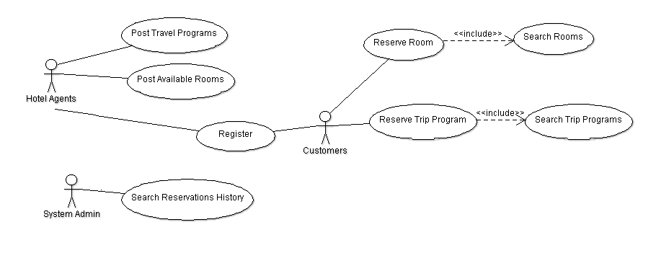

Actors

As depicted in the above diagrams, the main actors identified are:
- Hotel Agents – Has access to the transactional functionalities provided by the cloud system, in order to post available rooms and trip programs.
- Customers – Should be able to search rooms or trip programs, and reserve them,
- System Admin – Should be able to generate a history of reservations.

Logical View

Overview
According to the requirements, an architecture based on a SOA style, or a microservices architecture is a good fit for the system.

Most highly scalable and available cloud applications tend to move to a networked component model where applications are decomposed into micro services, which can be deployed and scaled independently; microservices-based architecture is the election to construct the system, because it provides several advantages to fulfil the cloud system requirements;:

- We can deploy each microservice is an independent software unit, so, each microservice can be replaced easily.
- Services will be organized around capabilities.
- We can implement a set of automated tests for each individual service.
- We can evolve the design for an individual service, without affecting others.
- It is to allocate additional computing resources to a single service, based on the resources demand.

These are the technologies to implement the solution, and the role of each in the overall architecture:

Apache CAMEL: For the microservices layer, Apache Camel allows us to develop the smart endpoints, and expose the microservices via camel-jetty as HTTP endpoints.

Also, Camel offers higher-level abstractions that allow you to interact with various systems using the same API regardless of the protocol or data type the systems are using. This is an important point, in case we need to evolve the system’s architecture to integrate any microservice with a third party system, without the need to convert your data to a canonical format.

MongoDB: MongoDB is the database for the data layer in the cloud system; the fundamental reasons for this choice are the following:
- We can evolve our schema, as the business requirements evolve, without affecting the previous design.
- We can embed data or collections, to provide a better performance, based on the use patterns of the application.
- We can serve any other set of systems or applications requiring the information, with a lightweight data-interchange format.
- We can implement the sharding pattern, to store data records across multiple machines

Apache Tomcat: This is the web server for the web layer. This is a choice based on the reason of Tomcat is one of the most common web servers, with a lot of engineers available to work with it.

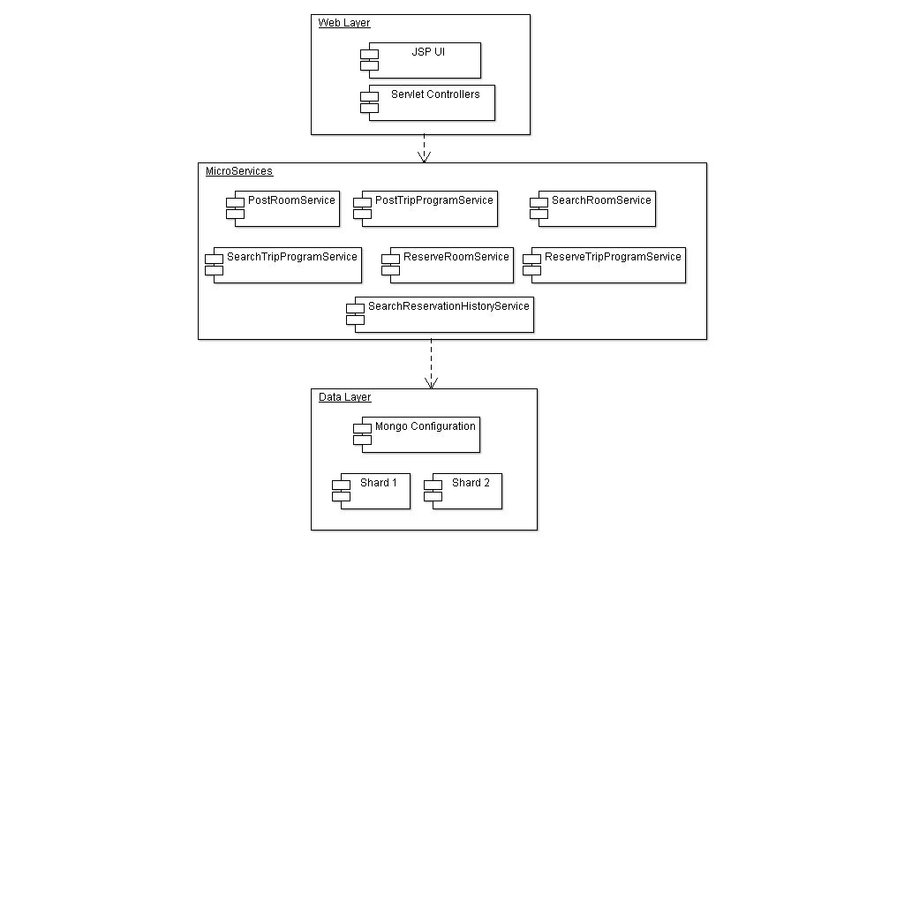

This is the organization of the logical view of the system:

Web Layer: This is the layer containing the web components for the system’s front-end, allowing the users to perform the use cases, such as book services, post rooms and trip travels. The components on this layer will communicate with the microservices deployed via HTTP Rest,and will present the information to the user.

Microservices Layer: This an architectural layer where the microservices are exposed to be consumed via HTTP Rest. Initially, the services will be deployed on the same single server, but they can be moved independently on to another servers, based on the resources demand.
Each service will be made up with its own data access layer, and business logic layer (if needed), to fulfil the business need for which the service was built.

Data Layer: This is the layer hosting the NonSql database, and the sharded cluster when the application needs to scale.

Cloud Patterns

Sharding
To access the high volume of information, we divide the data store into horizontal partitions or shards. This pattern is better explained and depicted in the deployment view.

Competing Consumers
Enable multiple concurrent consumers to process messages received on the same channel. The Apache Camel framework has a built-in implementation of such a pattern which we will use to scale the services horizontally.

Implementation View
The implementation view illustrates the system architecture from the view point of software management. For this purpose, we design the classes diagram for the main services.

Search Rooms Or Trip Programs
Each service will have a similar structure of classes; for this implementation, an individual service will be made up of the following structure of classes:
- A Route Builder
- A Service Implementation
- A main class the initialize the service
- A set of classes for the underlying data access layer

The attributes for each can extended or modified, as the requirements evolve and get clarified for each service.
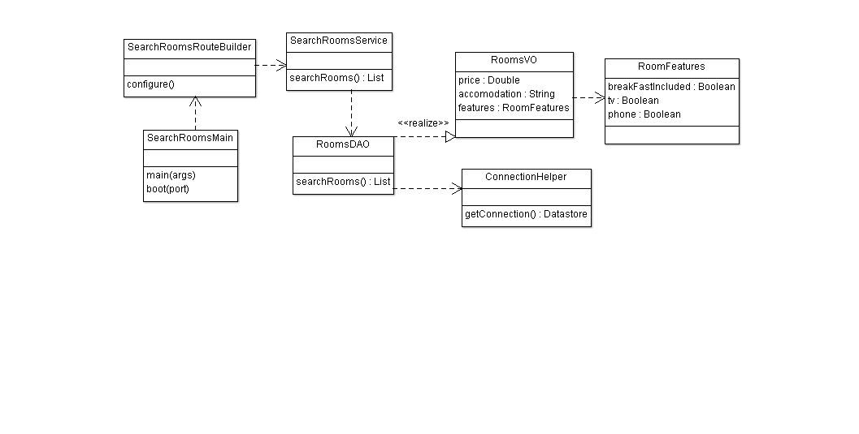

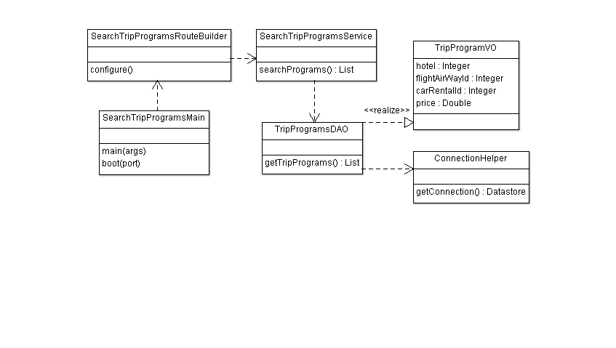

Reservation Services

The trip program reservation service will composed of the following classes:

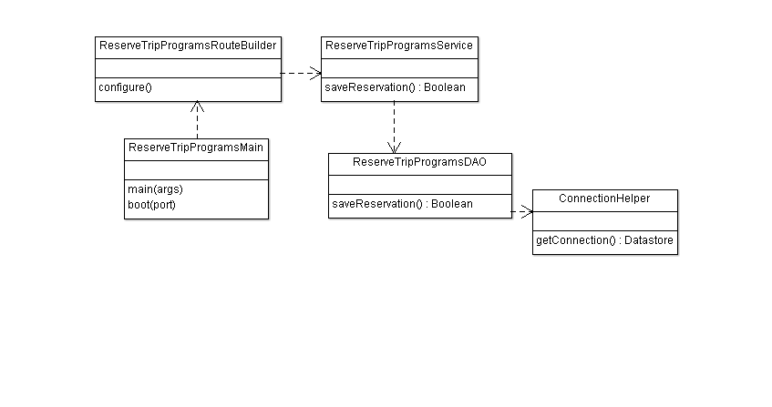
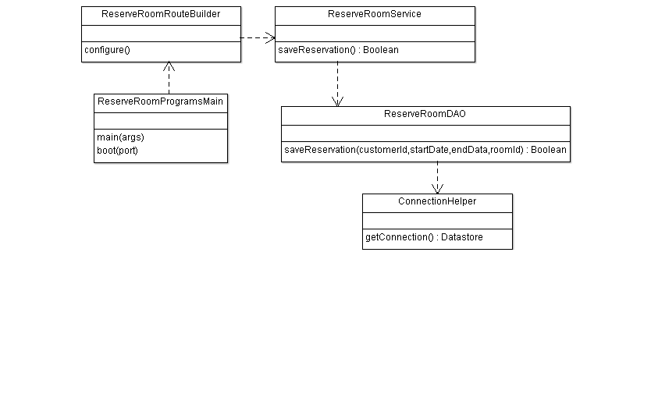

Reservations History Service

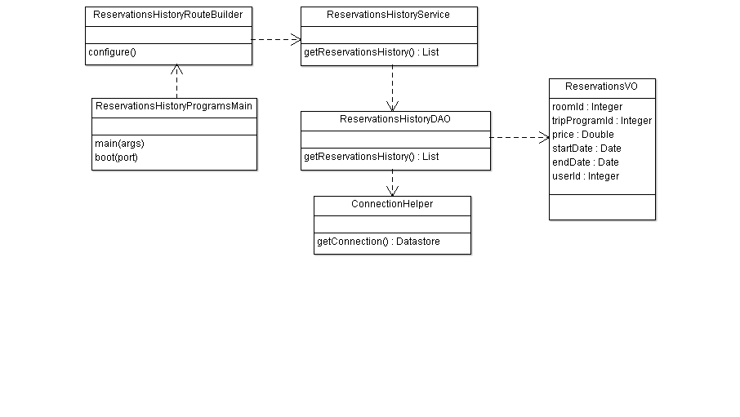

Posts Services

Here we outline the design of the service to post a room; the service to post a trip program will have a similar same structure, with classes implementing the specific logic to post a trip program.

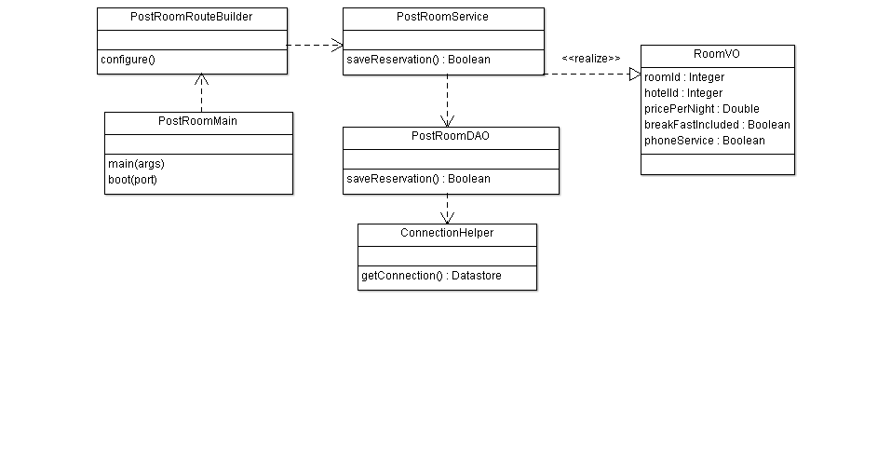

Login Service

The login service will return a JSON Web Token once an user is authenticated. The JSON Web Token can be shared across all the requests to the service, in order to provide access to the services, according to the user’s role.
We are electing to use JSON Web Tokens, to keep the backend stateless, for scalability.
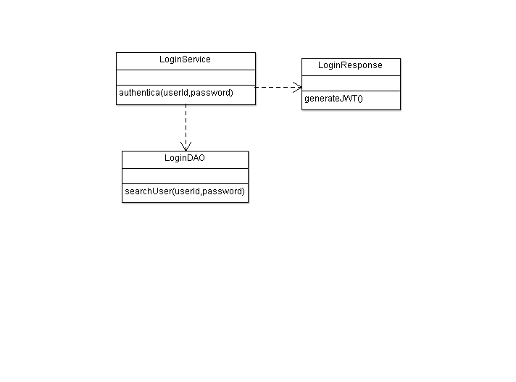

Packages Diagram
This is the high-level packages diagram, depicting the dependencies between the packages and their classes.
The low level packages, such as the APIs to connect with the data store are not included in this initial model; as such, it is assumed that the business services in its internal structure import those packages.
The package diagram outlines the packages structure for a microservice, but all the microservices defined in this architecture will have a common packages structure.
These are the packages description, to implemente the various microservices:

- Application Package: Contains the classes to initialize the microservice.
- Routes Package: Contains the route builders classes for the microservice.
- Dao Package: Contains the classes to data access classes.
- Service Package: Contains the classes implementing the business logic for the service.
- Domain Package: Contains any objects representing the information domain.

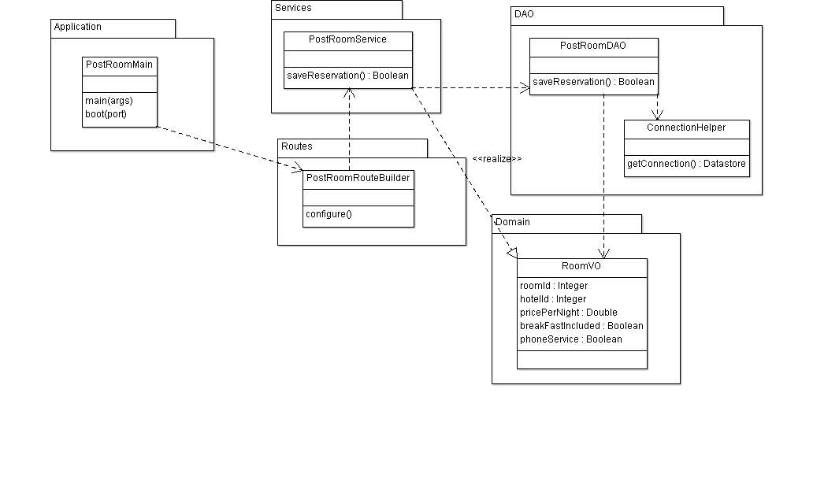

Data View
The data view represents the schema design for the data model in MongoDB for the cloud-based system. The document oriented database allows to work without constraints, which is an advantage for our design, as we can embed containers within another, for fast access to the information.

These are the main insights for the designed schema:
- We will have four collections, to store the documents associated with each entity.
- A single customer can make multiple reservations along the time, so, this information will not be embedded in the users documents; all the reservations will be stored in an independent, with relationships to the users documents, room documents and trip programs documents.

Note: When the booking system’s requirements evolve, and we need to manage multirow transactions, we would need to consider to setup a hybrid solution, for example with mysql in the backend to manage the booking operations if we need to integrate payments online to reserve the rooms or the trip programs, to ensure the integrity of the information.

Document Schema

Users

userId
userName
userLastName
userRole

Reservations

userId
roomId
tripProgramId
reservationStartDate
reservationEndDate

Rooms

accomodation
price
breakfastIncluded
phoneService
deluxeRoom
cableTV

TripPrograms

origin
destination
insuranceIncluded
numAdults
numChildren
numDays
hotelName
currency
carIncluded

Deployment View
The deployment model below is based on the following principles and cloud design patterns:
- No state is stored in the backend, so the application can scale horizontally infinitely (in theory).
- The sharding cloud-pattern is used to deploy the mongodb data store; each shard has the same schema, but holds its own distinct subset of the data.
- An elastic load balancer can be put in front, to distribute the load between services when needed.

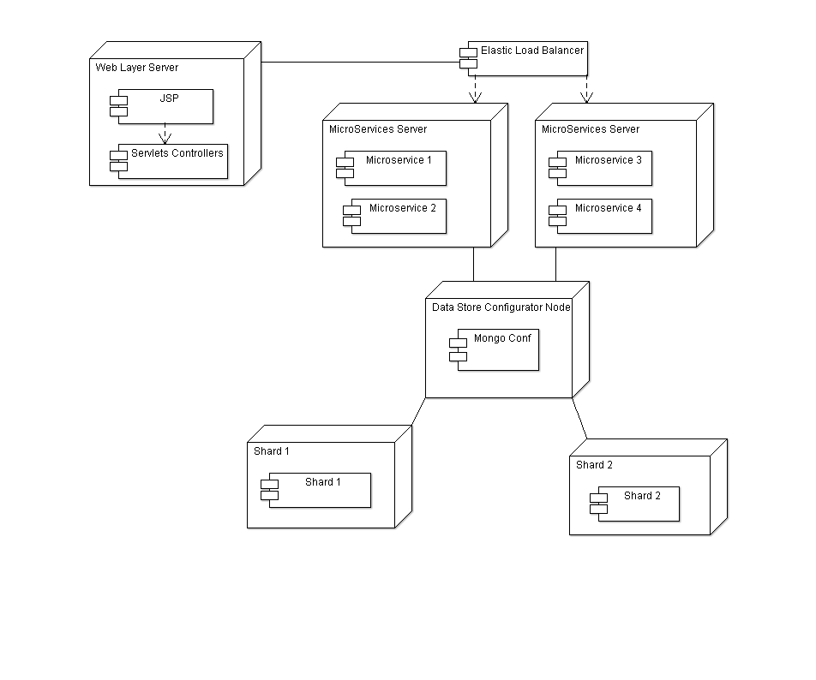

Security

We will leverage the security capabilities provided by Camel to deploy the cloud system, which are:

- Route Security - Authentication and Authorization services to proceed on a route or route segment
- Payload Security - Data Formats that offer encryption/decryption services at the payload level
- Endpoint Security - Security offered by components that can be utilized by endpointUri associated with the component
- Configuration Security - Security offered by encrypting sensitive information from configuration files

These are the security packages provided by Camel:

- Route Security
  - Provided by shiro-security component in Camel: it is a security focused component, based on the Apache Shiro security project; this camel shiro-security component allows authentication and authorization support to be applied to different segments of a camel route.

- Payload Security
  - The Crypto Data Format integrates the Java Cryptographic Extension into Camel, allowing simple and flexible encryption and decryption of messages using Camel's familiar marshall and unmarshal formatting mechanism.

- Endpoint Security
  - HTTP Basic Authentication & WS-Security support using the CXF Bus driven interceptor chain

JSON Web Token
The use of JSON Web Tokens will allow us to create a security layer, to grant access to the services, based on the user’s roles. The JSON Web Token can be shared across the requests, to validate the identity of the claim.

SAAS Vendor Integration

We expose a set of REST services, which can be consumed by a third party. An internal security layer is added, in order to validate the identity of the third for each request. We can share a JSON Web Token with the third parties, so our security layer can grant access to the right services to each claim.
